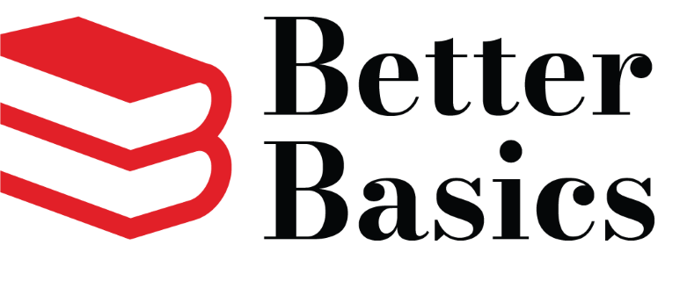

Better Basics Junior Board Application
Thank you for your interest in serving on the Junior Board. Better Basics is a 501(c)(3) children’s literacy nonprofit organization. Founded in 1993 on the conviction that economic disparities could be significantly alleviated by ensuring children could read, Better Basics works to eradicate illiteracy among children in Central Alabama. Beginning as a single program in the East Lake area of Birmingham more than 30 years ago, Better Basics has grown to twelve robust literacy programs reaching underserved children from birth through 12th grade. Today, Better Basics addresses persistent educational disparities through comprehensive reading and math literacy programs alongside book distribution initiatives.
This program year, Better Basics will provide more than 3,000 predominantly minority and low-income children with reading and mathematics skills needed to help close the achievement gap. They also build children’s home libraries by distributing over 100,000 high-interest, age-appropriate books.

The Junior Board of Better Basics members are a group of young professionals who support Better Basics as they work to fulfill their vision that all children become productive lifelong learners. Junior Board members will raise awareness and funding to support Better Basics by:
- Share Better Basics’ mission to eradicate illiteracy among children in Central Alabama.

  - Serve as an advocate for children’s literacy and Better Basics in the workplace and the community.

  - Serve as a volunteer reader at Better Basics Reads and volunteer with other Better Basics-hosted programs or events at least once per year.

  - Cultivate donors and sponsors for Better Basics programs and events.

  - Develop, plan, promote, and staff an annual fundraiser.

  - Attend monthly Better Basics Junior Board meetings – virtual and in-person.

  - Pay Junior Board annual donation of $75 for dues.

  - Contribute to Junior Board activities, such as Christmas family sponsorship, etc.

Junior Board members serve a rolling three-year term renewable for an additional term at the discretion of the Junior Board. For more information about Better Basics, please email aboone@betterbasics.org

JUNIOR BOARD MEMBER APPLICATION

Name/Age:

Employer/Title:

Address:

City/State/Zip:

Email: Phone:

College/Major:

- How did you learn of Better Basics?

- Why are you interested in being a Better Basics Junior Board member?

- Please list the strengths and skills that would contribute to the Junior Board.

- Please list any networks, relationships, resources, or community outreach skills you would bring to advocacy and fundraising for Better Basics.

- What other organizations are you involved with in the community?

- Anything else you want to share about yourself and what you can contribute to the Junior Board?

COMMITMENT AFFIRMATION

Please confirm that you commit to the responsibilities of a Junior Board member. Please check each item.

_____ Share Better Basics’ mission to eradicate illiteracy among children in Central Alabama.

_____ Serve as an advocate for children’s literacy and Better Basics in the workplace and the community.

_____ Serve as a volunteer reader at Better Basics Reads and volunteer with other Better Basics-hosted programs or events at least once per year.

_____ Cultivate donors and sponsors for Better Basics programs and events.

_____ Develop, plan, promote, and staff an annual fundraiser.

_____ Attend monthly Better Basics Junior Board meetings – virtual and in-person.

_____ Pay Junior Board annual donation of $75 for dues.

_____ Contribute to Junior Board activities – Christmas family sponsorship, socials, etc.

What committee(s) are you interested in serving on?

_____ Volunteer and Outreach _____ Events _____ Membership

__________________________________________ Signature _______________________________ Date

Please return to: Samantha.Warner@Protective.com

